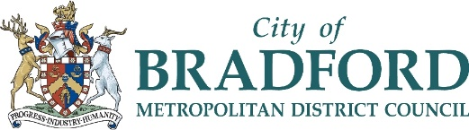
Thank you for your interest in working with us at Bradford Council.
Great things happen here in Bradford.
Big, young and diverse, we are home to more than half a million people, vibrant communities, innovative businesses and institutions. The District is alive with energy, enterprise and goodwill and represents unrivalled potential, a growing pipeline of talent and exceptional quality of life at the heart of the north.
Urban, bustling, streetwise, with award-winning public realm, yet two-thirds rural with beautiful landscapes, and open spaces on the doorstep the District offers leisure and lifestyle opportunities to suit everyone.

A dynamic cultural sector is at the heart of Bradford’s vision for social and economic inclusion. The District has a proud cultural heritage and an eye-catching and fertile contemporary offer, with world class exponents of literature, film, music, art and cuisine.
Global connections are reflected in Bradford’s status as a top UK exporter while high business start-up rates signal a thriving culture of enterprise in a £11.6bn economy, the country’s 10th largest. With 16,000 businesses generating a £30bn turnover, Bradford’s strengths include advanced manufacturing, chemicals, finance and automotive components and we have ambitions to be a national leader in delivering clean growth.
While there’s much to be proud of and much to look forward to. Like all big modern cities Bradford has its fair share of challenges. We’re working hard to tackle inequality and poor health, improve achievements in education and attract investment.
Being part of Team Bradford means being fully committed to working hard with our people, communities, partners and businesses to improve quality of life and get the best for our District. Every single one of us contributes to achieving those goals and so will you.
It means caring about what you do at work every day and being prepared to do whatever it takes to make sure our district and people fulfil their potential. It might be a challenge sometimes, but you will be part of a team that is on your side and wants you to succeed.
We want you to love your job and be the best you can be. And we will do our best to help you. You’ll benefit from a warm welcome and a sense of community. You’ll get support, opportunities to acquire new skills and chances to get involved in a whole load of activity outside of work.
Bradford is home to top class events and festivals and attractions like the award-winning City Park, Saltaire World Heritage Site and the Hockney gallery. A vibrant night time economy, including the renowned Alhambra Theatre and the unique Sunbridge Wells network of bars, shops and cafes, helps to showcase the country’s finest beer and curry.
Beyond the city limits, rugged and invigorating landscapes provide a magnificent outdoor playground to let off steam in and the District is fast becoming a magnet for cyclists wishing to experience first-hand the roads that have hosted the Tour De France and Tour De Yorkshire.
Above all, this is a place where community counts, making it brilliant to live and work in.

