Information Pack

Business Development Manager Outdoor Learning

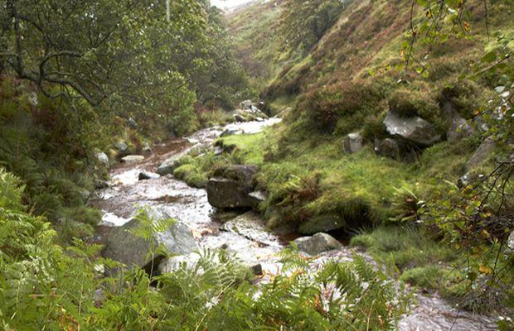

Bradford Council is looking to appoint a Business Development Manager to lead and manage the development of an outstanding and innovative outdoor learning offer, working across the 2 outdoor residential centres at Ingleborough Hall and Buckden House.

This information pack is designed to give insight into the Bradford District and the background to the 2 Outdoor Centres. It also outlines our expectations for outdoor learning going forward as part of the wider Youth Offer to our districts children and young people.

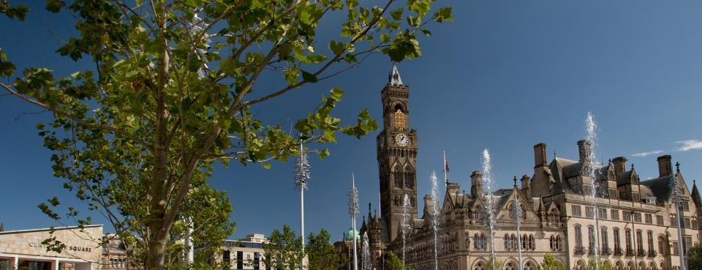

Bradford District
Bradford district is a large metropolitan district with a population of around 500,000 people. Almost a quarter of the population is under the age of 25 years and as such Bradford boasts the status of being one of the youngest cities in the UK. Numbers of children and young people are highest in our inner city wards where 40% of the population is aged 0-19 years. The health and wellbeing of children in the district is generally worse than the England average and child poverty and obesity rates are higher than England averages. We have a higher than average number of young people with disabilities growing up in the District.

Services for children, young people and families in Bradford are being delivered against a backdrop of significant financial pressure and reducing budgets and at a time of significant policy change across health, social care and education.

There has been unprecedented change in the way education services are organised over recent years. Nationally the academy programme has been accelerated and free schools, established by independent groups and organisations, but funded by central government have been introduced. The rise in multi-academy trusts is changing the landscape both in relation to local developments and trusts from out of the area working with some of the Bradford schools. There is a sector led approach towards school improvement and an ambition to accelerate education attainment and achievement in the district.

Bradford as a district has some extraordinary assets and strengths, it is enterprising and energetic. It is a district that celebrates, commemorates, works and plays together and has truly inclusive public spaces which are amongst the most diverse in the country.

The Youth Offer
Bradford Council has a statutory obligation to “secure services and activities to improve young people’s well-being”. In Bradford we call this the Youth Offer and this is delivered by a broad range of partners across the youth sector which includes the local authority youth services, the voluntary, community, faith and uniformed groups. We rely on a strong and vibrant outdoor offer for children and young people seeing this as a key element in their personal and social development.

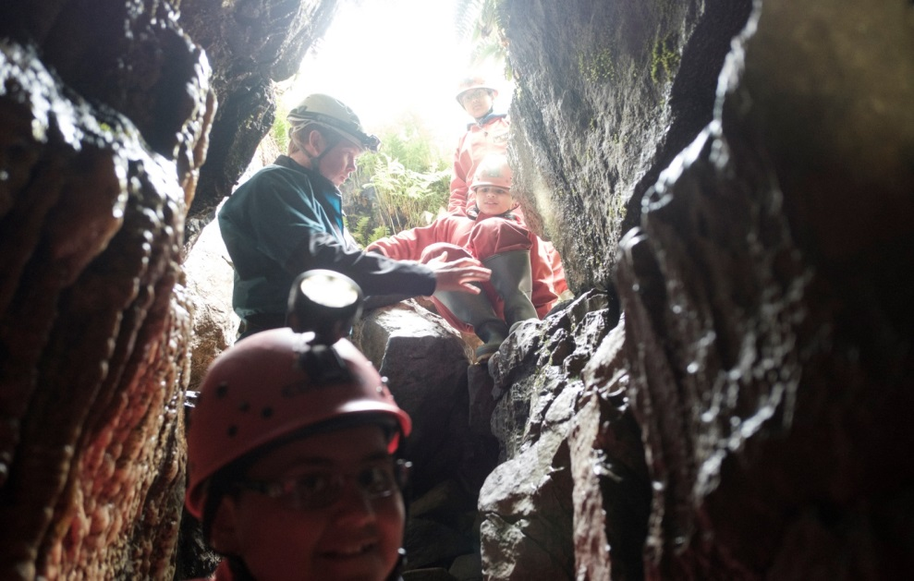

Outdoor Learning
Bradford Council currently retains management of 3 outdoor education centres within the Children’s Services Department. This includes Nell Bank Outdoor Education Centre in Ilkley, Ingleborough Hall in Clapham and Buckden House in Buckden. The 3 Centres, together with colleagues from Environment and Sport’s Adventure Development Team and the Doe Park Water Activity Centre provide a varied and progressive menu of outdoor learning across all age ranges.

Bradford Council with support of the Schools Forum has made significant investment into the Outdoor Education Centres, with £1.7 million being invested in capital works over the last 3-4 years at the sites at Nell Bank, Ingleborough Hall and Buckden House.

The Development Manager for Outdoor Learning would have responsibility for the sites at Ingleborough Hall and Buckden House and will be expected to ensure these centres offer a complementary outdoor learning offer for the districts children and young people, whilst securing a unique identity for each setting.

Ingleborough Hall Outdoor Education Centre

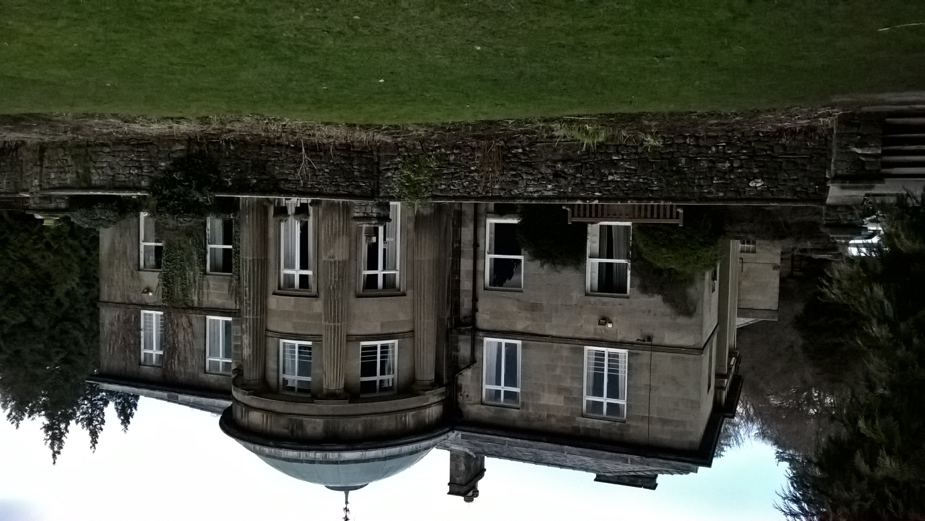

Ingleborough Hall, is sited in Clapham village in the Yorkshire Dales. (OS Sheet OL2 GR 746 693). It was built around c1840 and was originally the country house of Reginald Farrer, It has also operated as a boarding school for sick children and as a safe space for evacuees prior to its conversion to an outdoor education centre in 1974. It boasts a grade 2 listing with some stunning grounds and mature woodlands of approximately 50 hectares. It has unique features including an old ice house and a servant tunnel to the local village.

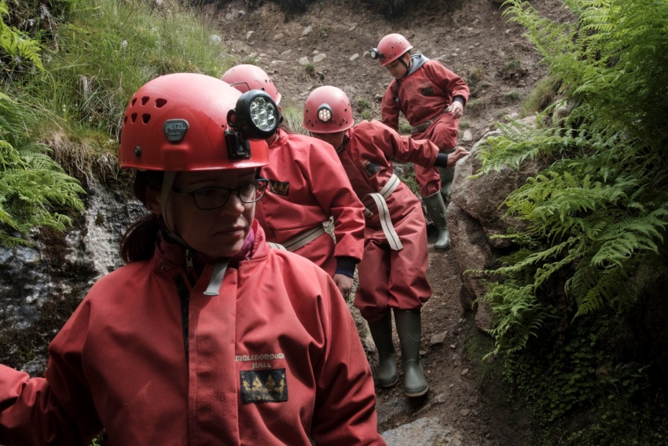

Buckden House Outdoor Education Centre

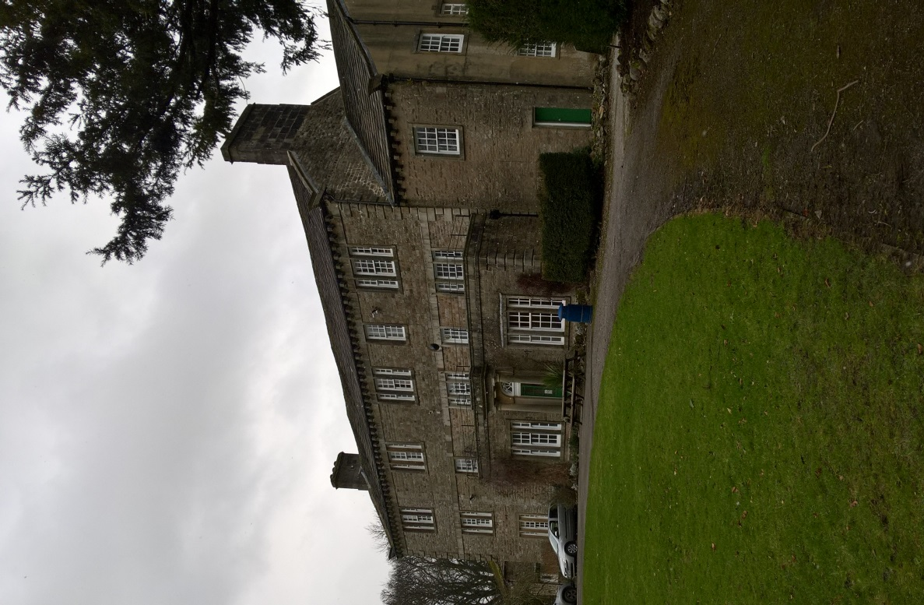

Buckden House is sited in the village of Buckden in the Yorkshire Dales (OS Sheet OL2 GR 942 771). The original 2 story house with 3 bays was built in the Mid C18, with a third story and 2 additional bays being added in the C19. The early history of the house is lined with the Heber and Ramsden families, having been acquired following dispersal of the Duke of Devonshire’s Upper Wharfedale Estate. The most significant major alterations took place around 1879 when General Crompton Stansfield took ownership of the house for his daughter Elizabeth. The estate and house were sold in 1945 and again in 1967 and has operated as an outdoor education centre since 1974.

Both sites are surrounded by the beautiful Yorkshire Dales, an area of outstanding natural beauty, full of stone built villages, stunning landscapes and vibrant communities. The existing outdoor learning offer currently ensures full use of the hall and house, their grounds and the countryside surrounding both sites. We offer a varied range of outdoor adventure and learning activities that includes:

- Archery
- Caving
- Climbing Wall (on site)
- Ghyll Scrambling
- Gorge Walking
- High Ropes Course (on site)
- Orienteering
- Rock Climbing
- Abseiling
- Team Building
- Village Studies
- Low Level Walks
- Hill Walking and Mountaineering
- Improvised Rafting

Both Centres are registered in line with Adventure Activities Licensing requirements and hold the Learning Outside the Classroom Quality Mark.

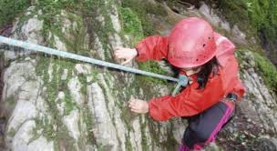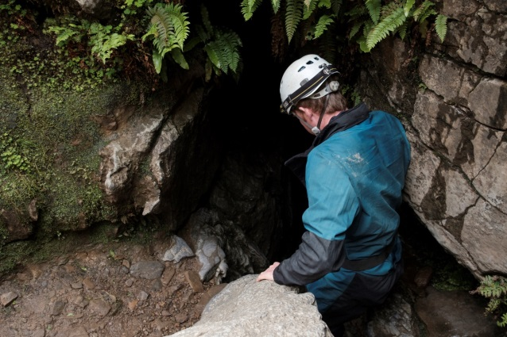

The Future
Bradford Council is facing some huge challenges in terms of reducing budgets and significant financial pressures. This is impacting on all our services to children, young people and their families, and this includes our outdoor learning offer.

However, in facing some of these challenges there are also opportunities that include building a sustainable future for the outdoor education centres. Options for this are at early consideration stages, including exploration of alternative structures and management arrangements that are independent of the local authority. The successful candidate will be a Business Development Manager who has vision and creativity to be able to develop and drive forward ideas, ensuring the successful placement of the outdoor offer from the centres in the wider market place of outdoor learning.

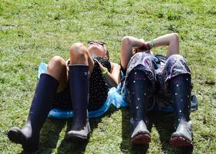

Business Development Manager – Outdoor Learning

GRADE: PO5 SCP 44 – 47 £39,177- £41,967 pro rata
37 hours per week

This is an exciting opportunity to manage and lead the development of an outstanding and innovative outdoor learning offer, working across the 2 outdoor residential centre sites at Ingleborough Hall and Buckden House.

The post holder will be responsible for leading the commercial management of the Centres to ensure an outdoor learning offer that has clear curriculum links and is in line with statutory guidance and best practice.

The successful candidate will develop business strategies, working alongside key stakeholders and centre users to ensure a joined up, exciting, flexible and innovative learning offer that increases the customer base, turnover and profitability, making best use of the Outdoor Centres.

The role will work with managers in Children’s Services and other key departments to develop appropriate Trust arrangements for the Outdoor Centres and for the Councils wider Outdoor Learning Offer.

The successful candidate will have:
- A recognised degree qualification in an appropriate area eg outdoor education, finance, marketing or management studies
- One or more of the following – BCA Cave Instructor Certificate / MLT Mountaineering Instructor Award, BCA Local Cave Leader Level 2 Award; MLTE Mountain Leader Award; MLTE Single Pitch Award
- 3 years experience of managing outdoor residential centre provision
- A high level of business acumen and flair
- Demonstrated leadership in terms of commercial development, income generation and implementation of business strategies
- Demonstrated ability to increasing customer base, turnover and profitability of a service area
- Sound understanding of safety polices, procedures and regulations, including risk management in outdoor learning environments
- A good breadth of knowledge and working practice of compliance with national guidance and statutory compliance, for the delivery of outdoor education
- A good knowledge of education curriculums and the opportunities outdoor education offers to enhance pupil / student learning
- Experience of managing and supervising staff and the ability to provide inspirational leadership to your team.
- The ability to build and develop the service working in partnership with others.
An enhanced disclosure check with the Disclosure & Barring Service will be required for this post

A relocation package would be considered for the suitable candidate.

Potential candidates are invited to attend informal visits to the Outdoor Centres
- Ingleborough Hall – Tuesday 17th October 2017 between 11am and 12.30pm
- Buckden House – Tuesday 17th October 2017 between 2.30pm and 4pm
Please book attendance via: heather.wilson@bradford.gov.uk

Further questions can be directed to Heather Wilson – Commissioner (Youth Provisions) on 01274 431781, mobile number 07582 100 692

Closing date for applications: Sunday 29th October 2017

