CITY OF BRADFORD METROPOLITAN DISTRICT COUNCIL
JOB PROFILE

DEPARTMENT: Corporate Resources | SERVICE GROUP: Estates & Property
POST TITLE: Estate Surveyor | REPORTS TO: Estates Manager – Acquisitions & Disposals
GRADE: PO3/PO4 |  | SAP POSITION NUMBER :

The following information is furnished to help Council staff and those people considering joining the City of Bradford Metropolitan District Council to understand and appreciate the general work content of their post and the role they are to play in the organisation. The duties and responsibilities highlighted in this Job Profile are indicative and may vary over time. Post holders are expected to undertake other duties and responsibilities relevant to the nature, level and scope of the post and the grade has been established on this basis. For posts where employees speak directly to members of the Public the post holder is required to demonstrate their ability to speak fluently in English.

The employee competencies are the minimum standard of behaviour expected by the Council of all its employees and the management competencies outlined are those relevant for a post operating at this level within our organisation.

Both sets of competencies will be used at interview stage and will not be used for short listing purposes. As a candidate/employee you will be expected to demonstrate your ability meet the special knowledge, experience and qualifications required for the role.

Key Purpose of Post:
To work in the Estates & Property Department within the Acquisitions & Disposals team of chartered surveyors:

- To ensure that all the requirements of the Council which involve the use of land and property are met in the most appropriate and effective way and that its property assets make optimal contribution to corporate and service priorities and strategies.

- To assist with the effective management and where appropriate disposal of the council’s land and property holdings.

- To maximise capital receipts and revenue income of the Council, generated through land and property transactions and the acquisition of assets to fulfil the revenue demands of the Council

Main Responsibilities of Post:
Bradford District is the fifth largest metropolitan district in England, after Birmingham, Leeds, Sheffield and Manchester with a population in the order of 534,999. The City of Bradford MDC is the local authority of the city of Bradford but covers a larger area extending to some 143 sq miles and includes towns such as of Keighley, Shipley, Bingley, Ilkley, Haworth, Silsden, Queensbury, Thornton and Denholme.

The Council employ approximately 8,500 people (excluding schools).

The Council’s officers implement the decisions made by the councillors and to deliver frontline services. The most senior Council officer is the Chief Executive. The Chief Executive is supported by the Corporate Management Team which includes Corporate Resources within which sits the Estates & Property team.

Estates & Property cover a wide variety of property related matters managed within three teams responsible for Strategic Asset Management (the operation of the Council’s occupied estate), Estate Management (managing the Council’s investment portfolio) and the Acquisition & Disposals team.

The opportunity is to join a team of 6 Chartered Surveyors and property professionals to work within the Acquisition & Disposals team.

- The duties of the Estate Surveyor may be performed in any of the work areas of the Service depending on priorities.

- The Acquisition & Disposals team acts across many aspects of the Council’s property and land assets. It has a market focus being primarily responsible for all acquisitions, and disposal of surplus assets.

- Roles are diverse to include; development for housing and other uses, working with public sector partners, procurement of planning consents and ownership issues.

- The team deals with the sale of surplus assets either by sale by private treaty or via auctions. This may involve the use of external consultants.

- The team deals with the acquisition of investment assets that assist the regeneration strategies of the Council.

- The Council has an extensive land bank. A key element of the role is to assist in developing a strategy that brings the land forward for sale or development. This will involve assessing key sites and master planning, obtaining planning consents, engaging with developers and key public sector partners.

- The team advises on the acquisition of property and land through the use of CPO powers.

- Provide property advice and undertake valuations and negotiations for regeneration projects including property development, financial appraisals and joint venturing agreements.

- To work with the Acquisition & Disposal Manager to assist in a rolling programme of Capital Receipts and other service functions, balancing fluctuations and changing demands in workloads and dealing creatively with change in accordance with Council’s objectives/policies, legislative requirements and Department and Service Plans.

- Collaborate with colleagues across the Council, including, for example, planning colleagues, asset management and housing development to identify and unlock development opportunities from surplus council land. Using surveying expertise to unlock and add asset value to projects within other Service areas. To assist regeneration and job creation throughout the district.

- To deputise for the appropriate Principal Officer or Assistant Director as required.

- To represent, if required, Estate Management at working parties, Committees, Sub-Committees or Board Meetings when required involving the preparation of reports and the provision of appropriate professional advice.

- To contribute to ensuring the most efficient and effective use of the Council’s assets to maximise the potential benefits to regeneration programmes objectives through those assets.

- To develop and encourage the development of partnering with other Agencies, Organisations and Public Bodies in the use and management of assets.

- To prepare committee reports and member briefings and to present reports to committees as required.

- Bradford is an Equal Opportunities Employer and as such employees are required to comply with good Equal Opportunities practice in every aspect of their work.

- To be accountable for those appropriate responsibilities as set down in the Council’s Health and Safety Policies and in addition to take reasonable care for their own health and safety and that of others who may be affected by the work of the post-holder.

- To carry out any other duties as required, which are reasonable in terms of the nature and level of the post.

- If required to represent the Councils estate investment interests through active engagement across the Leeds City Region, West Yorkshire Combined Authority & LEP programmes.
- To write, draft and contribute to the preparation and presentation of reports to Project Boards, Council Committees and other groups as required.
- To demonstrate experience of complex property disposals and valuations.

Structure: Acquisitions & Disposals Team - Estates & Property Department
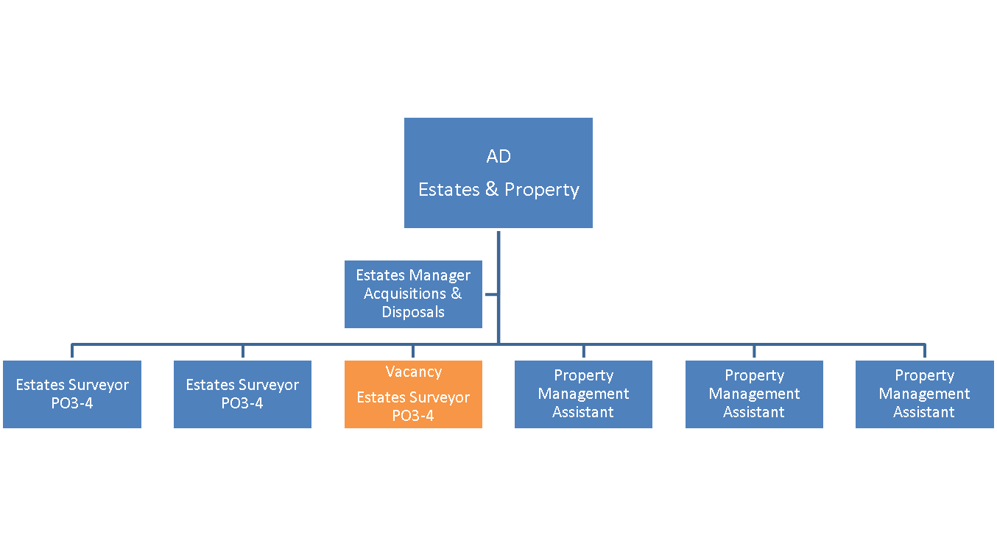
Special Knowledge Requirement: Will be used in shortlisting.
Applicants with disabilities are only required to meet the essential special knowledge requirements shown by a cross in the end column.
 | Essential
Due to the Governments Fluency in English Duty for posts where employees speak directly to members of the public the post holder is required to meet the Advanced threshold level which will be implemented where the post requires a greater level of sensitive interaction with the public,( e.g. in children’s centres) – where the person is able to demonstrate that they can during the interview:  a) Can express themselves fluently and spontaneously, almost effortlessly  b) Only the requirement to explain difficult concepts simply hinders a natural smooth flow of language | Y
Carries out the working practices, procedures and basic operations across a number of specialist areas related to General Practice surveying | Y
Carries out a variety of specialist professional; or general managerial responsibilities effectively, with a considerable depth of knowledge across the relevant specialist area, or knowledge across a range of areas.  Understands the service issues in a local authority environment and is able to give advice to more senior managers in own area of specialism. | Y
Uses specialist knowledge of health, safety and environmental policies , procedures and regulations, including risk in own area and/or across other areas Inc. legislation and regulatory compliance | Y
Uses, interprets, analyses, communicates complex numerical information.  Analyses and presents statistical/numerical information using graphics eg management information requests, presentations, information leaflet, booklets | Y
Uses a wide range of basic computer applications  Uses ICT systems/packages to improve ways of working and for sharing information in own work area. | Y
Uses, interprets, analyses and communicates complex information from a variety of sources relating to detailed investment and development appraisal and analysis. | Y
A good understanding of the principles of Estate Management relating to a varied property portfolio. | Y
A good understanding of a range of property valuation techniques and methods of disposal.  Uses a range of specialist ICT systems including development appraisal software across own work area and or across other areas of work including but not limited to a knowledge of and ability to apply management data and intelligence systems | Y
Knowledge of Local Authority procedures and practices relating to property and asset management. | Y

Relevant experience requirement: Will be used in shortlisting

The applicant is required to provide evidence of having previously spoken fluently to members of the public in order to meet the advanced threshold level outlined under Special Knowledge above.

Chartered Surveyor status with RICS (professional membership) in General Practice with at least 3 years relevant professional experience including at least one year as a qualified chartered surveyor. At least 5 years post qualification experience to progress to the highest salary grade.

Must have a broad range of experience in the acquisition and disposal of property by way of lease or sale; valuing a wide range of property interests, general property and asset management.
Core Employee competencies at manager level to be used at the interview stage.

Carries Out Performance Management
Produces a workable and reviewable delivery plan which addresses identified needs.

Communicates Effectively
Speaks clearly and uses simple language appropriate to the situation and audience in order to build and maintain a dialogue (develop a common understanding).

Speaks and writes in plain English and produces clear concise information to the public.

Able to draft basic/routine letters, emails and reports in a logical and accurate manner.

Able to demonstrate adequate verbal skills in discussion, negotiation and when giving advice

Carries Out Effective Decision Making

Identifies and interprets data which is relevant to the situation.

Reaches logical decisions which stand up to 3rd party scrutiny.
Undertakes Structured Problem Solving Activity

Looks at problems in the round, exploring the issues from a number of viewpoints or perspectives to fully understand its complexity and identify the underlying issues involves.

Checks out potential solutions with experts/specialist knowledge holders to ensure that they meet legislative requirements and that the degree of risk has been accurately calculated.

Operates with Dignity and Respect

Covers treating everyone with respect and dignity, maintains impartiality/fairness with all people, is aware of the barriers people face.

Management Competencies: to be used at the interview stage.

Operates with Strategic Awareness

- Understands the main issues that affect the council.
- Shows awareness of Council priorities and strategy.
- Accepts and follows corporate policies and procedures.

Practices Appropriate Leadership

- Acts as a role model within the team.
- Listens and responds to the differing needs of individuals.

Delivering Successful Performance

- Plans, organises and prioritises own workload effectively to meet deadlines.
- Gives regular updates to others on progress towards meeting targets.
- Makes sure quality standards are kept

Applying Project and Programme Management

- Knows who the service’s customers are and their relevant requirements from your own area of operations.
- Sets out tasks in a logical schedule.
- Able to accurately estimate time required to complete tasks.

Developing High Performing People and Teams

- Treats others fairly & consistently.
- Creates and maintains good working relationships to facilitate collaborative working.

Working Conditions:

Must be able to perform all duties and tasks with reasonable adjustment, where appropriate, in accordance with the Equality Act 2010 in relation to Disability Provisions.

Must be able to work evenings, weekends and bank holidays as required by the
needs of the service.

Must be capable of carrying out inspections of land and property.

Special Conditions:
You will be informed if there is a requirement for the post to have recruitment checks.
Such as DBS, Warner Process.

Compiled by:  A Russell  Date: 18.02.2021 | Grade Assessment Date: | Post Grade:  PO 3/4

