RACE EQUALITY NETWORK
Project to support BAME communities with poor health outcomes in the Bradford District in light of COVID-19
Chair, Yusuf Karolia
Background
During the Covid 19 Pandemic health inequalities amongst the BAME communities became very apparent. The vulnerability of these groups was highlighted repeatedly throughout the past few months of the pandemic. Research, surveys, newspaper articles, media debates were rife and decision makers expressed major concerns on the impact of the virus on BAME sections of the UK population.
We have however been aware of greater levels of public health inequalities amongst BAME communities for a very long time. Policy conclusions and the prevailing wisdom is that BAME communities have a greater propensity to suffer poor health mainly as a result of poor outcomes linked to the wide range of health determinants. Indeed, the World Health Organisation has emphasised that the conditions in which people are born, grow, live, work and age are important health determinants and that these circumstances are shaped by the distribution of power, money and resources. Covid-19 and its impact on BAME communities have totally vindicated the prevailing belief that BAME communities suffer disproportionately the effects of poor health.
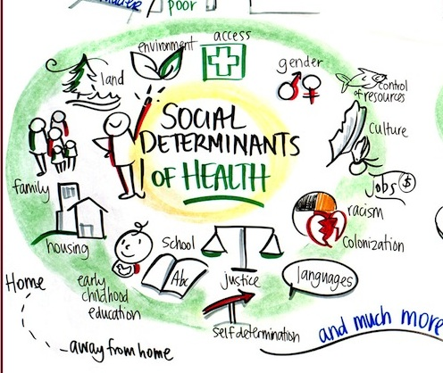
The following two illustrations of social determinants of health apply to various sections of the population in varying degrees but the relative impact on BAME communities has always been believed to be greater. The reason often given is to do with co-morbidities and the various factors combining together to compound the effects on BAME households.
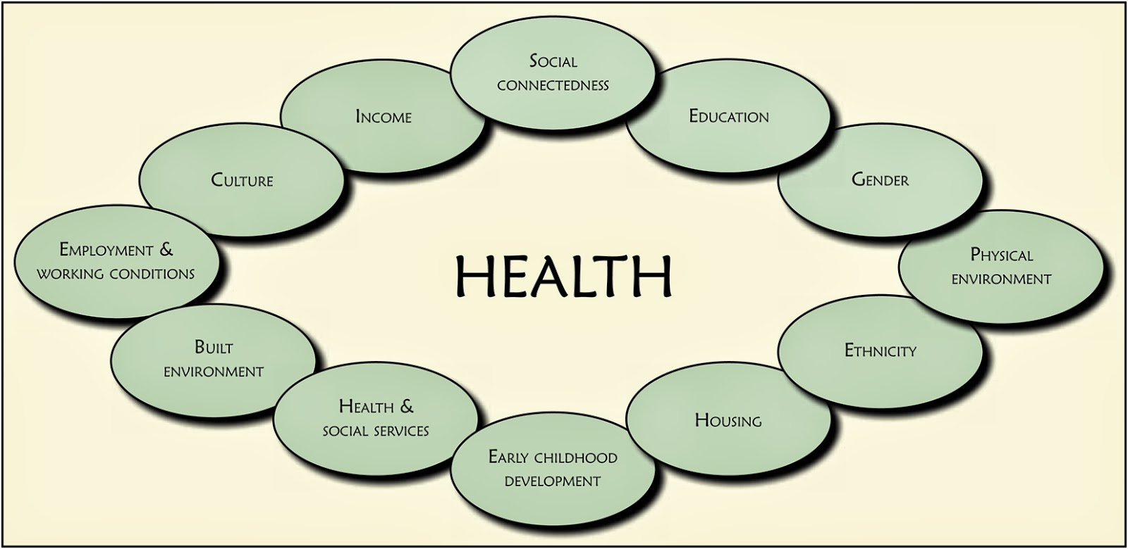

Public Health England recognises the above social determinants of health and states that BAME groups generally have less access to high quality care along with poorer health and worse health outcomes than the overall population. It cites the example of the risk of developing diabetes is 6 times higher in some BAME groups. Covid-19, says Public Health England, has shone a spotlight on health inequalities that have existed for decades. It cautions that whilst co-morbidities and socio-economic status are being put forward as possible explanations for the high number of people from BAME backgrounds affected, it is important not to assume that co-relations equals causation. Discrimination and racism also play a part in factors driving health inequalities. (Public Health England Review on disparities in the risk and outcomes of COVID-19)
The following findings and conclusions are causing major concerns to local and national policy and decision makers. There is also widespread concern and anger particularly within BAME populations that not enough is being done by the Authorities to address the disparities being experienced by BAME groups, not only with Covid-19 but more generally with health outcomes and poverty levels.

Findings by the Social Metrics Commission
- BAME households were more than twice as likely to live in poverty as their white counterparts, leaving them disproportionately exposed to job losses and pay cuts caused by the coronaviruses pandemic
- Latest findings by the commission found that nearly half of Black African Caribbean households were in poverty, compared with just fewer than 1 in 5 white families. BAME families as a whole were between 2 and 3 times as likely to be in persistent poverty as white households
- Everyone in poverty, particularly those classed as in “deep poverty” i.e. those living below the 50% breadline, were far more likely to suffer reduced incomes since lockdown, increasing the risk that the pandemic would drive a significant increase in the incidence and severity of poverty
- BAME households were more likely to be living in deep poverty than white households. Around 1 in 10 adults from a Black British, Pakistani, Bangladeshi or mixed background were unemployed, compared with 1 in 25 White British. This means they were more likely to suffer heightened financial exposure to the pandemic
- A survey by the Social Metrics Commission of 80,000 adults carried out between 25 March and 18 May found that 65% of those in deep poverty prior to the crisis had suffered reduced earnings, job losses or furlough. This compared to 35% of those living in families with incomes more than 20% above the poverty line
- 46% of Black, 42% other ethnic, 39% Asian, and 32% of mixed ethnicity were found to be in poverty compared with 19% of White families.

Public Health England Review on disparities in the risk and outcomes of COVID-19
- The review confirms that the impact of COVID-19 has replicated existing health inequalities and, in some cases, exacerbated them further, particularly for BAME groups
- Risk of dying among those diagnosed with COVID-19 was higher in males than females; higher in those living in more deprived areas than those living in the least deprived areas; and higher in those in BAME groups than in white groups
- When compared to previous years the review found a particularly high increase in all cause deaths among those born outside the UK and Ireland; those in a range of caring occupations, including social care and nursing auxiliaries and assistants; those who drive passengers in road vehicles including taxi and minicab drivers; those working as security guards and related occupations; and in care homes
- The findings highlight that the relationship between health and ethnicity is complex and that the increased risk of acquiring the infection is linked to BAME groups being more likely to live in urban areas, overcrowded households, in deprived areas or work in job roles that could expose them to higher risk. Other barriers identified are access to services or language differences.

Going Forward
There is widespread concern about insufficient action to address the health inequalities and the resultant higher risk of acquiring and dying from COVID-19 regarding BAME households and there are calls for urgent action.
Papers produced prior to COVID 19 are helpful to revisit such as Public Health England’s, Local action on health inequalities, understanding and reducing ethnic inequalities in health produced in 2018. This paper considers various social determinants of health and its links to ethnicity and sets out actions to address them.
These include:
- Mainstreaming ethnicity
Without explicit consideration of ethnicity within health inequalities work there is a risk of partial understanding of the processes producing poor health outcomes and ineffective intervention.

- Influencing decision-makers and role of senior leadership
Progress on ethnic health inequalities has been slow and the need for senior leadership on this agenda has been repeatedly highlighted.

- Data collection, analysis and reporting
Gaps in data collection must be filled and there must be more consistent analysis and reporting of data on ethnicity, health and healthcare so that there is adequate understanding of local needs and the extent to which they are being met by policies and services. Action on the wider social and economic determinants of health may exacerbate ethnic health inequalities unless it adequately takes into account the ethnic patterning in residential, income, educational and occupational profiles.

- Tackling racism and ethnic discrimination
The central role of racism must be acknowledged, understood and addressed. There is an urgent need to build the evidence base around effective action.

- Local action on health inequalities
Understanding and reducing ethnic inequalities in health

- Commissioning of culturally sensitive health promotion interventions
Interventions need to work with cultural and religious understandings and values while recognising intra-group diversity and avoiding stereotyping.

- Improving access, experiences and outcomes of health services
Actions at organisational level include: regular equity audits; use of Health Impact Assessments; integration of equality into quality systems; good representation of black and minority ethnic communities among staff; sustained workforce development and employment practices; trust-building dialogue with service users

- Engagement with minority ethnic groups
Across all areas of activity, the meaningful engagement and involvement of minority ethnic communities, patients, clinical staff and people is central to understanding needs and producing appropriate and effective responses or shaping services. A concerted effort is required by public and private sector employers and service providers.

- Making use of evidence
The evidence base to inform policy and practice remains limited but more can be done to mobilise the available evidence and to document and evaluate promising local practice both locally and nationally

The report focuses on explanations for health inequalities (as set out below) and action to tackle them:
Education
Employment
Income and poverty
Housing
Multiple deprivations
Racism, discrimination and harassment
Social networks, social isolation and loneliness
Migration and mobility
Regional variation
Health related practices, e.g. smoking and healthy eating
Health literacy
Use of primary care and community health services
Access to secondary care

There is valuable detail in the report on the above set of determinants and this should be considered to develop local action.
The report also provides practice examples such as Bradford’s City Talent Management Programme; Action on health literacy: engaging South Asian men with diabetes in Stoke on Trent; and free universal distribution of Vitamin D in East Lancashire.
Bradford District consists of a significant BAME population which exhibits a range of health related and poverty issues as set out in various local documents. Strategies are already in place such as Connecting people and place for better health and well being, and Happy, Healthy and At Home, which can act as a springboard to action.
With a possible local lockdown in Bradford following data which suggests Bradford cases are relatively high and follows Leicester, which is already in a local lockdown, action needs to be taken urgently to prevent a resurgence of the virus.

Project Outline
What we will deliver and how
The key objective of the project is to:
Raise awareness amongst BAME communities in the District of the need to prevent infection of the Virus by following government guidance and any local guidance issued by the Council’s Public Health Department. Part of this awareness programme will also highlight impact of and on wider social determinants of health. The project will also support Public Health, Bradford, to deal with local outbreaks or to support communities at particular risk of an outbreak.
Some of the lessons from the Public Health England report, Local action on health inequalities, understanding and reducing ethnic inequalities in health produced in 2018, whilst pre-Covid-19, could be applied locally for long lasting impact, and the proposal set out below is seen as the start of concerted action to address health inequalities starting with dealing with the effects of COVID-19.
In focussing on infection prevention and control it is important to consider the underlying health inequalities and to put in place measures to deal with the wider social determinants. There is considerable good practice which exists and some of this is set out in the 2018 Public Health report and other reports. The project will therefore consider long term actions and work with relevant agencies and public authorities to deal with the social determinants which are adversely impacting on the Districts BAME households.
The project aims to tackle the immediate impacts of COVID-19 as a starting point by raising awareness amongst BAME communities working jointly with BAME led and BAME focussed community organisations.
A Hub and Spoke model would operate with Community Anchors (Hubs) and Community Champions (Spokes). The Hubs would be limited to 4 organisations selected for their reach, capacity and ability to deliver the objectives of the project. Spokes will support the Anchors with schemes which are bespoked to meet particular community needs.
We will require the Hubs and Spokes to recruit community volunteers and establish community champions from those volunteers to disseminate messages and respond to specific local responses by Public Health. This will include responding to identified local outbreaks.
Funding will be provided to 4 Anchors to support REN to meet the objectives of this project. Small grants will also be provided to community groups and organisations with discrete project ideas. This may include costs of recruiting volunteers and community champions.
The criteria for the community projects will be jointly developed with the Anchors and applications will be considered by REN and its Anchor partners.
The Race Equality Network (REN) will lead this effort and appoint the Anchor organisations and work closely with them to disseminate messages. Messages will be via, local media and social media and posters in public places.
We will also carry out community capacity building by engaging directly with communities as social media alone will not be sufficient due to language and cultural barriers.
We will consider ways to sustain the benefits of the project long term and influence public sector agencies to deliver services which are culturally oriented and which takes into account the impacts of the social determinants of health.

Notable Quotes:
“In Bradford we have to be cautious otherwise we will be another Leicester and we don’t want to be another Leicester. Everybody should be on red alert”, Professor John Wright

“When the data is compared between Bradford and the rest of the West Yorkshire and Harrogate region, it was clear that the number of cases in Bradford had not declined as much. Out of 140 hospital inpatients, 56 (40%) of them were in Bradford districts six hospitals. Of the 18 patients in ICU, more than half, 10 were in Bradford” Shaun Milburn, Deputy Director Operations, Bradford Teaching Hospitals Foundation Trust

“With the economic and social impacts of the coronavirus likely to last long after the health crisis is over, these results show how far we have to go to improve the lives of the most disadvantaged in society, and more work was urgently needed to understand why BAME households were disproportionately likely to live in poverty, and what solutions would drive improvements, from skills and work opportunities to housing. We should be looking to level up for the BAME community”, Social Metrics Commission Chair, Philippa Stroud

“Race is clearly a significant factor even if we cannot explain all the reasons why this may be the case. It is striking that people of Bangladeshi background had twice the risk of death than white people and African Caribbean people having up to 50% of the number of deaths. More research is needed to understand the impact of COVID-19 on known inequalities“, NHS Confederation statement

