CITY OF BRADFORD METROPOLITAN DISTRICT COUNCIL
JOB PROFILE

DEPARTMENT: Children’s Services | SERVICE GROUP: Education and Learning
POST TITLE: SEND Children’s Participation Officer | REPORTS TO: Transformation and Compliance Manager
GRADE: SO1/SO2 |  | SAP POSITION NUMBER : 50213898

The following information is furnished to help Council staff and those people considering joining the City of Bradford Metropolitan District Council to understand and appreciate the general work content of their post and the role they are to play in the organisation. The duties and responsibilities highlighted in this Job Profile are indicative and may vary over time. Post holders are expected to undertake other duties and responsibilities relevant to the nature, level and scope of the post and the grade has been established on this basis.
For posts where employees speak directly to members of the Public the post holder is required to demonstrate their ability to speak fluently in English.

As a candidate you will be expected to demonstrate your ability to meet the special knowledge, experience and qualifications required for the role by providing evidence in the application form for the purpose of shortlisting. Applicants with disabilities are only required to meet the essential special knowledge requirements shown by a cross in the end column of this section.

The employee competencies are the minimum standard of behaviour expected by the Council of all its employees and the management competencies outlined are those relevant for a post operating at this level within our organisation.

Both sets of competencies will be used at interview stage and will not be used for short listing purposes.

Key Purpose of Post:
To directly contribute to achieving the aims of the Service including:

.
- To support the development of social participation models for children and young people in Bradford.

- To work with schools, and other agencies to manage the democratic models of engagement with children and young people as part of a forward plan of democracy.

- To work in partnership with other agencies to support the development and implementation of Childrens rights and welfare across the Local Area for SEND.

Main Responsibilities of Post:
- To work alongside the SEND Team to help shape and implement our new models of children’s and young people’s participation in Bradford.
- To support local school, colleges and other providers to facilitate models of a democratic voice for children with SEND.
- To act as a champion for young people to bring awareness and raise attention to elements that matter to young people with SEND so that they have a voice in shaping decisions across the Local Area.
- To oversee and manage the forward plan of engagement for young people with SEND.
- To administrate and oversee all meetings that are put in place to support the young person’s voice.
- To work effectively with partner agencies to support market shaping and effective young person’s engagement for SEND in Bradford.
- To actively encourage and work with providers to increase social; participation approaches in Bradford for children and young people with SEND.
- To support the development of appropriate signposting for schools, families and children to activities in Bradford.
- To ensure the appropriate participation of children, young people and families in the co-design of new services where appropriate.
- To ensure that records are kept in accordance with the policies, procedures and standards of the department.
- To maintain and develop communications and co-operation with colleagues, individuals and groups in the community and other statutory and voluntary agencies.

The duties and responsibilities highlighted in this Job Specification are indicative and may vary over time. Post holders are expected to undertake other duties and responsibilities relevant to the nature, level and scope of the post and the grade has been established on this basis.
Structure:

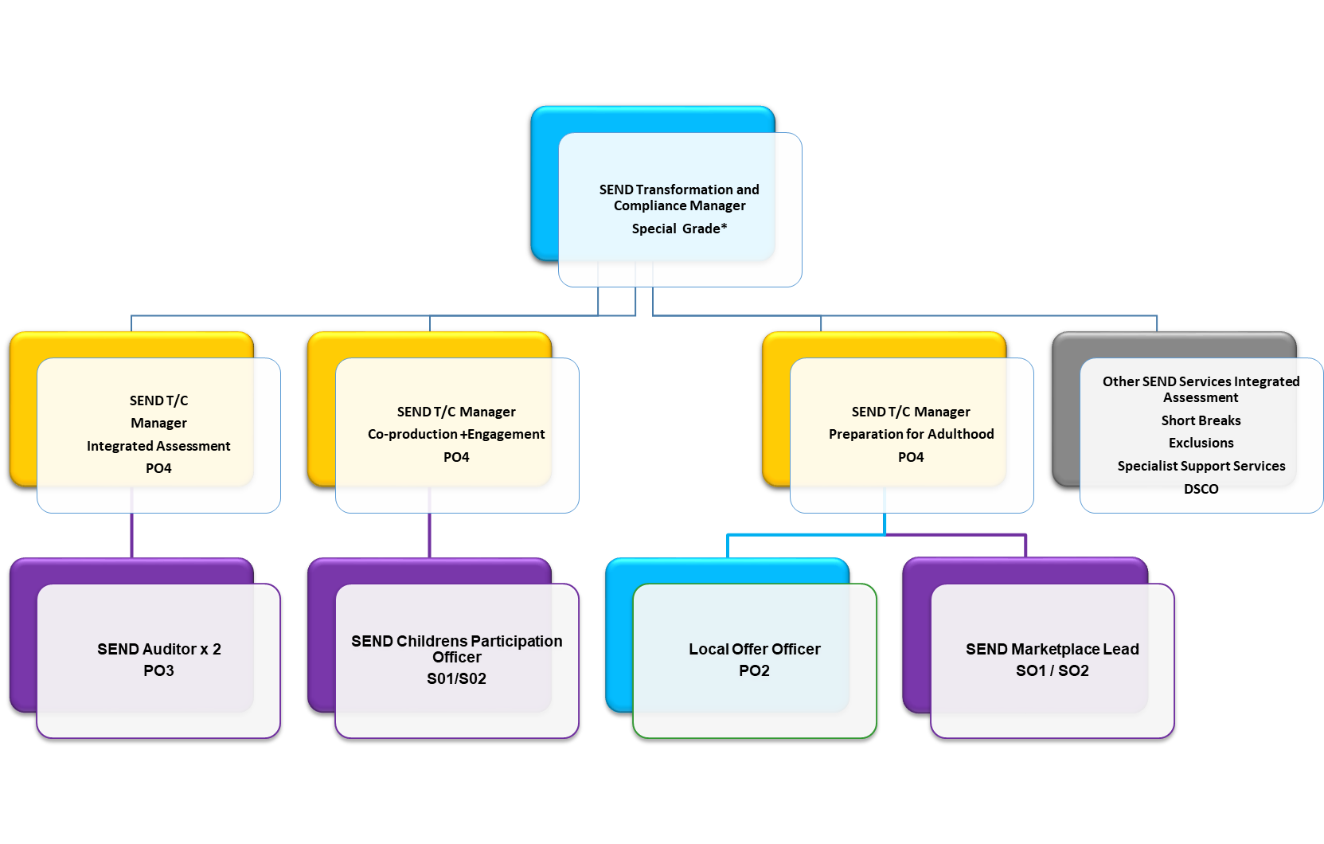
Special Knowledge Requirement: Will be used for shortlisting.

Applicants with disabilities are only required to meet the essential special knowledge requirements shown by a cross in the end column.
Essential
Due to the Governments Fluency in English Duty for posts where employees speak directly to members of the public the post holder is required to meet the Advanced threshold level which will be implemented where the post requires a greater level of sensitive interaction with the public, (e.g. in children’s centres) – where the person is able to demonstrate that they can during the interview:
a) Can express themselves fluently and spontaneously, almost effortlessly
b) Only the requirement to explain difficult concepts simply hinders a natural smooth flow of language

Knowledge of engagement and participation models for children and young people
Knowledge of SEND Services and SEND systems
Knowledge of the Bradford Local Area and how schools are structured
Knowledge of models of democracy and their core functions
Applicant can use a wide range of basic computer applications including case management systems.
Knows and understands how to analyse, interpret and present complex information from a variety of sources that can help inform what services are needed in a local area.
Working knowledge of relevant sections of the Children and Families Act 2014, Children Act 1989, Chronically Sick and Disabled person act 1970 and Working together to safeguard Children
Knowledge of how to use word-processing and spread sheet software

Relevant experience requirement: Will be used for shortlisting

The applicant is required to provide evidence of having previously spoken fluently to members of the public in order to meet the advanced threshold level outlined under Special Knowledge above.
- At least 3 years’ experience of working with children and young people
- Experience of working in a SEND Environment
- Experience of managing and arranging meetings
- Experience of managing a forward plan
- Experience of undertaking analysis to determine what services are needed in a local area or district
- Experience and working knowledge of a Local Offer for SEND
- Experience of use of ICT systems, procedures and casework, preferably in the field of SEND.
- Experience of managing workload to meet statutory deadlines.
- Highly developed analytical skills to interpret and summarise complex information and a proactive approach to problem-solving.
Relevant professional qualifications requirement: Will be used for shortlisting

- Degree or equivalent qualification or evidence of the ability to work at that level.

Core Employee competencies at manager level to be used at the interview stage.

Carries Out Performance Management – covers the employee’s capacity to manage
their workload and carry out a number of specific tasks accurately and at a high standard.
Communicates Effectively - covers a range of spoken and written communication skills required as a regular feature of the job. It includes exchanging information/building relationships, giving advice and guidance, counselling, negotiating and persuading and handling private, confidential and sensitive information.
Carries Out Effective Decision Making - covers a range of thinking skills required for taking initiative and independent actions within the scope of the job. It includes planning and organising, self effectiveness and any requirements to quality check work.
Undertakes Structured Problem Solving Activity - covers a range of analytical skills required for gathering, collating and analysing the facts needed to solve problems. It includes creative and critical thinking, developing practical solutions, applying problem solving strategies and managing interpersonal relationships.
Operates with Dignity and Respect - covers treating everyone with respect and dignity, maintains impartiality/fairness with all people, is aware of the barriers people face.

Management Competencies: to be used at the interview stage.

Operates with Strategic Awareness Our managers work with corporate priorities and policies in a joined up way with others, internally and externally. Works democratically, transparently and accountably.
Practices Appropriate Leadership Our managers motivate their staff to exceed expectations through raising their awareness of goals and moving them beyond self interest for the sake of the team or service. They consider serving the District in all that they do.
Delivering Successful Performance Our managers monitor performance of services, teams & individuals against targets & celebrate great performance. They promote the District’s vision & work to achieve Council’s values & agreed outcomes.
Applying Project and Programme Management Our manager’s work to ensure that outcomes and objectives are achieved within desired timescales, make best use of resources and take a positive approach to contingency planning.
Developing High Performing People and Teams Our managers coach individuals and teams to achieve their potential and take responsibility for continuous improvement. They champion the Council’s values and goals.
Working Conditions:

Must be able to perform all duties and tasks with reasonable adjustment, where appropriate, in accordance with the Equality Act 2010 in relation to Disability Provisions.
Special Conditions:
You will be required to consent to an enhanced DBS Check for the role.

Compiled by:  Stu Barratt  Date: March 22 | Grade Assessment Date: | Post Grade:

Version 2
June 2019

